BIKE CRASH DETECTION

Mr. Afroj Alam, Abhi kiran, Harshith N R, Shiva Kumar, Eshwar Raju A G

Department of Computer Science, Presidency University, Bengaluru, Karnataka, India

UG Students, Department of CSE, Presidency University, Bengaluru, Karnataka, India

|  |  |  |
| --- | --- | --- |
| **keywords** |  | **Abstract** |
| **Arduino Nano**  **ADXL335Accelometer**  **GSM SIM800l**  **Neo 6m GPS Module**  **Lithium Battery**  **LM2596 Step Converter**  **Zero PCB**  **Power supply** |  | This study describes the design and implementation of a complex system for detecting bike crashes that makes use of the integration of a number of different parts, such as an Arduino Nano, an ADXL-345 accelerometer, a GPS Neo-6m receiver, a GSM SIM800l module, an LM2596 step converter, a Zero PCB, a power supply, and a lithium battery. By offering quick notification in the case of a mishap and real-time monitoring, the proposed system seeks to improve bike safety. One of the most important sensors for spotting abrupt accelerations suggestive of an impending collision is the ADXL-345 accelerometer. When something is detected, the GSM SIM800l module is triggered to send an alert message to designated emergency contacts via the Arduino Nano, which then processes the accelerometer data. Furthermore, precise location data is obtained via the GPS Neo-6m module, assisting emergency personnel in arriving at the scene of the incident.  The effective operation of the components is ensured while keeping a small and energy-efficient design thanks to the inclusion of an LM2596 Step Converter and a dependable power source. The system's overall performance is optimized by the Zero PCB, which makes it easier to connect and arrange the numerous modules in an ordered manner.  In-depth testing and real-world simulations were carried out to verify the efficacy of the suggested bike crash detection system. These showed the system's capacity to quickly and precisely identify crashes, pinpoint their position, and send out alerts in a timely manner. The findings suggest that by speeding up response times in emergency scenarios, this system has the potential to greatly improve bike safety.  This study adds to the expanding body of knowledge in the field of intelligent transportation systems and emphasizes the value of combining cutting-edge sensor technologies with microcontroller platforms for improved |

# INTRODUCTION

Recent years have seen a rise in creative methods to lessen the frequency and severity of accidents due to growing concerns about road safety. Among these initiatives, a lot of focus has been placed on developing cutting-edge technologies for early detection and quick reaction to traffic accidents. An important area of concern is the startling increase in bicycle accidents, which raises concerns about urban mobility and transit safety in addition to endangering the expanding number of bikers.

A proactive approach is required to decrease the frequency of bike crashes and improve emergency response systems because these accidents are frequently caused by a complex interaction of elements, including road conditions, human error, and environmental variables. Investigating the latest developments in technology, this study examines the developing field of bicycle collision detection systems..

Intelligent systems that can recognize and react to bike crashes in real-time are becoming more and more necessary as urban landscapes change to accommodate a variety of modes of transportation. In order to develop systems that can quickly communicate with emergency services and detect accidents, researchers and engineers have made use of cutting-edge sensors, machine learning algorithms, and communication technologies.

Through an analysis of their shortcomings, opportunities for improvement, and effectiveness, this paper seeks to present a thorough review of the state-of-the-art bike collision detection systems. It also looks at the larger effects these technologies may have on traffic safety, how smart city projects fit in, and how they might affect infrastructure development and policy decisions. Understanding and improving bike collision detection systems will surely be essential to promoting a safer coexistence between bikers, drivers, and pedestrians as we navigate a future marked by rising urbanization and a greater emphasis on sustainable mobility. By supporting the creation of resilient and adaptable technology to safeguard vulnerable road users and advance a more safe and inclusive transportation ecosystem, our research adds to the continuing conversation about road safety.

# Proposed Methodology

The world's most dangerous mode of transportation is thought to be motorcycling. According to a National Highway Traffic Safety Administration survey, there are around 212.7 recorded motorcycle deaths for every 100 million vehicle miles traveled (VMT). Motorcycles continue to be the leading cause of deaths in the transportation industry, despite significant safety improvements over the previous few decades. These days, motorcycle accidents happen often.According to the National Highway road Safety Administration, motorbikes made up 3% of all vehicles registered in the United States in 2019 alone, but motorcycle riders were responsible for 14% of all road fatalities. That year, an estimated 84,000 motorcycle riders also suffered injuries in collisions. Motorcycles are quite risky by nature. But cautious driving techniques and Helmet use can lower fatalities and injuries. Motorcycles and left-turning cars frequently have deadly collisions. According to a 2019 NHTSA analysis, a left turn was made at the scene of over half of all fatal collisions involving both vehicles and motorcycles.

The purpose of this paper is to identify a motorbike crash, verify that the crash is not a false positive, and then notify the designated emergency contacts about the place and time of the crash. This will provide the recipient enough information to contact the appropriate authorities at the crash scene right away and offer the assistance they need.

Additionally, in the unlikely event that the crash occurs nearby, this will make it simpler for the receiver to find the scene and determine the scope of the damage. In order to recognize whether a motorcycle has overturned and a crash has occurred, a sensor known as the MPU 6050—a multi-axes accelerometer and gyroscope sensor—is used. The position status is updated to the Firebase database upon a fall, and the rider's smartphone reads this information. Once the latitude and longitude are obtained, the smartphone notifies the emergency contact listed in the app itself about the collision. A button can be easily pressed by the driver to dismiss a false alarm. The steps necessary to create a bike collision detection system with emergency message capabilities are described in this proposed methodology, which integrates components such as the Arduino Nano, GPS NEO-6M, GSM SIM800L, ADXL-345 accelerometer, and LM2596 Step Converter. Sufficient testing and optimization are essential to guarantee the system's dependability and efficiency in practical situations.

# Hardware Description

1. Arduino Nano

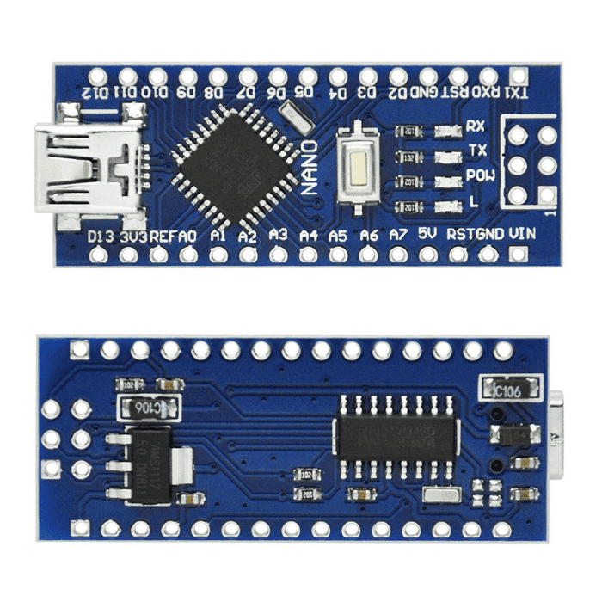

Fig 3. Arduino Nano

Arduino created the tiny, adaptable, and reasonably priced Arduino Nano microcontroller board. It belongs to the Arduino family and is intended for applications that call for a lightweight, small board with a variety of features. The Arduino Nano has the following salient characteristics:

1.Microcontroller:The Arduino Nano is powered by the ATmega328P microcontroller, which is also the same chip that powers the Arduino Nano.

2. Size and Form size: The Nano's tiny form size, which makes it ideal for applications with limited space, is one of its distinguishing features.

3. Pin Configuration: The Nano's pinout is reminiscent of the larger Arduino boards, such as the Uno, giving users used to older Arduino models a comfortable interface.

4. Voltage Regulator: The Nano's integrated voltage regulator allows it to operate with a broad range of input voltages, usually between 7 and 12 volts, and output a steady 5 volts.

5. USB Interface: The Nano has an integrated USB interface that makes it simple to connect it to a computer for power and programming.

6. Clock Speed: The Nano's ATmega328P normally runs at 16MHz, which offers enough processing capability for a range of uses.

7. Memory: It has two KB of SRAM for variables, one KB of EEPROM for non-volatile data storage, and thirty-two KB of flash memory for the software.

8.I/O Ports: There are several digital and analog input/output pins on the Nano, which enable flexible connections to actuators, sensors, and other parts.

9. Programming: The Arduino Nano may be programmed using a USB connection and the Arduino IDE. The Arduino language, which is a condensed form of C/C++, allows users to develop programs.

10. Compatibility: The Nano is compatible with various Arduino shields and modules, enhancing its versatility for different applications.

11. Applications: The Arduino Nano is frequently utilized in a variety of applications, such as wearable technology, embedded systems, robotics, and other electronics projects where a limited amount of space is a crucial component.

12. Community Support: The Nano is fortunate to have a sizable and vibrant community since it is a component of the Arduino ecosystem. Users can get help and collaborate from the comprehensive documentation, tutorials, and forums available. The Arduino Nano provides a small and powerful foundation for a wide range of electronic applications, making it ideal for hobbyists, students, and professionals alike. The maker community favors it because of its adaptability and simplicity of usage.

B. LM2596 Step Down Power Module:

The LM2596 Step Down Power Module is a voltage regulator module that is essential to electronic circuits because it effectively converts higher input voltages to a stable and lower output voltage. This module is especially helpful in projects where sensitive components or devices require a consistent power source because it uses a buck converter topology, which allows it to step down the input voltage while increasing the output current to provide a steady and dependable power source. The LM2596 is widely used in a variety of applications because of its small size and ease of use, including microcontroller and sensor powering in electronic projects as well as being an essential part of battery charging circuits. It can adapt to the different voltage requirements of various electronic components thanks to its adjustable output voltage capability. All things considered, the LM2596 Step Down Power Module is highly regarded for its effectiveness, small size, and versatility, which makes it a vital tool for engineers, enthusiasts, and hobbyists.

c. Power Supply Module: A power supply module is a crucial part of electronic systems because it provides a steady, controlled electrical voltage to power different parts of a circuit. These modules, which are available in several varieties such as switching and linear power supplies, are made to transform input power from a source—like a wall outlet or battery—into a steady output voltage appropriate for the electronic devices that are connected to them. In order to preserve the associated components' safety and longevity, the power supply module not only controls voltage but also frequently incorporates other functions like temperature, short circuit, and overcurrent protection. In electronics, power supply modules are essential components that allow microcontrollers, sensors, and other integrated circuits to function dependably. They are essential in a variety of applications, from consumer electronics to industrial automation systems, because to their adaptability and capacity to adjust to various input sources and voltage needs.

D. GSM Module:

Designed to provide GSM (Global System for Mobile Communications) connectivity in electronic products and projects, the SIM800L GSM module is a small and adaptable communication module. The SIM800L, created by SIMCOM, is a popular device for SMS-based applications and mobile communication. This module allows for worldwide mobile communication compatibility by operating on multiple GSM frequencies. Because of its compact form factor, it can be integrated into projects with limited area. The SIM800L allows internet connectivity in addition to conventional voice calls and SMS messages because it supports GPRS (General Packet Radio Service) for data transmission. The module can be readily setup and controlled by a microcontroller or other host device after its AT command is established. It is energy-efficient and appropriate for battery-operated applications because to its low power consumption and standby modes. In IoT (Internet of Things) projects, remote monitoring systems, and other applications where mobile communication is crucial, the SIM800L GSM module is frequently used as a dependable and reasonably priced wireless connectivity option.

E. Accelerometer

Designed to measure acceleration in three dimensions (X, Y, and Z), the ADXL335 accelerometer is a very adaptable sensor that offers useful data for a variety of applications. Based on MEMS (Micro-Electro-Mechanical Systems) technology, Analog Devices manufactures this analog accelerometer. It is made up of a collection of minuscule microstructures that generate electrical impulses in reaction to variations in acceleration. A suspended mass element that responds to acceleration forces is present in each of the three sensitive axes of the ADXL335 device. Analog voltage outputs proportionate to the applied acceleration are produced by the shifting masses, which also generate fluctuations in capacitance.. The ADXL335 is a versatile device that may be used for tilt sensing, motion detection, vibration analysis, and other applications due to its large dynamic range and low power consumption. It is well-liked by engineers, researchers, and amateurs for incorporating precise motion-sensing capabilities into a variety of electrical projects, from wearable technology and inertial measurement units to robotics and drones. This is due to its small size and ease of use.

**F.** NEO-6M GPS Module

The NEO-6M GPS module is a small and effective Global positional System (GPS) receiver that can deliver precise and up-to-date positional data. The NEO-6M, made by u-blox, is outfitted with cutting-edge navigational technology that allows it to pick up signals from many satellites in orbit around the planet and determine its exact location, elevation, and speed. This module makes use of the MediaTek chipset, which has a short time-to-first-fix (TTFF) and a high degree of sensitivity, making satellite signal pickup fast and dependable. Through a serial communication protocol, the NEO-6M exchanges data with a host microcontroller or device. NMEA (National Marine Electronics Association) phrases are commonly used in this communication. The NEO-6M GPS module has gained popularity for projects requiring precise and timely position data because to its tiny form factor, low power consumption, and interoperability with a wide range of applications, such as tracking devices, navigation systems, and unmanned aerial vehicles (UAVs). Because of its adaptability and simplicity of integration, it is a useful part of location-based application development for a variety of sectors. Result and Conclusion

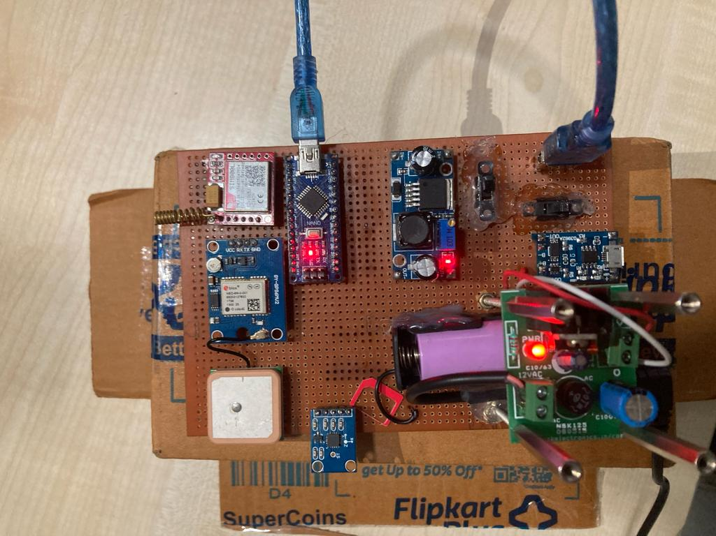

Fig 1. Hardware setup

The hardware setup was thus successfully developed and tested. Figure 11 shows the hardware module and the results are successfully obtained for sending information to the designated emergency contacts, including the victim's name, vehicle number, and contact number, along with the accurate location of the victim using latitude and longitude data. Figure 12 shows a screenshot of the information the victim's information was sent to the command center and emergency contacts. In comparison to car crashes, bike crashes are generally far more difficult to identify. Bicycle crashes are successfully identified with this method. Sending inaccurate crash information is prevented in this system. It will precisely identify any kind of crash and transmit an emergency SOS (Save our soul) signal to a central command center. Saving lives is the ultimate goal, and this approach can help do that.

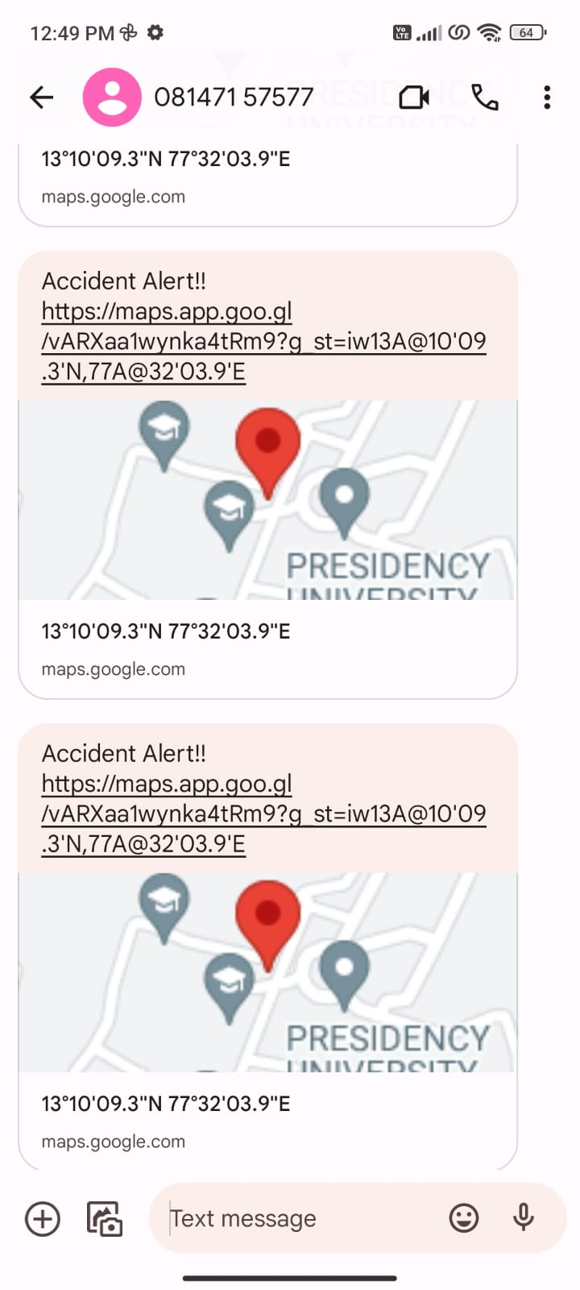

Fig 2. Message received screenshot obtained from mobile

This paper presented an overview on vehicle crash detection and information system for two wheeler in remote areas.

# Result and Conclusion

As a result, the hardware configuration was created and tested without incident. and results are successfully acquired for transmitting an information to the Hardware Module, as shown in Figure 1. provided Emergency contacts with information about the victims, including their names, vehicle numbers, and contact numbers; the victim's precise location is determined using latitude and longitude data, which is gathered quickly and efficiently by accurately sensing modules; figure 1 shows a screenshot of the information that the command center and Emergency contacts received about the victim. In general, identifying bike crashes is far more difficult than identifying car crashes. Through the use of this technique, bike crashes are efficiently identified. This technique prevents the transmission of inaccurate accident information. It is capable of precisely identifying any kind of crash and sending an emergency SOS (Save our soul) signal to a central command center. This system can help achieve the ultimate goal, which is to preserve lives.

# Conclusion

This method gives the medical community accident data. rescue teams can be extremely beneficial and even life-saving when they arrive moments after the accident. It can greatly lessen the medical personnel' response time and preserve the victims' lives. This is merely the technical portion; more resources are required for the actual, large-scale execution. This system sends an alert message via GSM and uses GPS to pinpoint the location after successfully detecting an accident using data from accelerometers and vibration sensors. Using GPS, the alert message is sent to the closest medical facility.

The program also has a "cancel" option that may be accessed via the Android application on the user's phone in the event of false alarms or if the user does not want immediate assistance. This option is only accessible for 10 seconds. To track a vehicle for anti-theft purposes, the Android application can be used to obtain the location of the vehicle. In the event of theft, the user can use the program to remotely stop the engine. They are also notified when and where the vehicle is started. These days, accident detection and alert systems are very important, and the goal of this project is to create a low-cost solution for the good of society.

# References

1.https://ieeexplore.ieee.org/document/8117791 Intelligent Accident Detection and Alert System for Emergency Medical Assistance

2. Automated Car Accident Identification and Messaging System Utilizing GSM and GPS Modem "http://www.rroij.com/open-access/automatic-vehicle-accident-detection-and-messaging-system-utilizing-gsm and GPS modem.php?aid=44586"

3. Development of a Motor Cycle Accident Detection and Warning System Fahim Bin Basheer, Naveed K. Farhan, Raghu C. V., Jinu J. Alias, Mohammed Favas C, Navas V, and Fahim Bin Basheer

4. Smartphone-Based Intelligent Autonomous Vehicle Accident Detection and Alerting System: <https://ieeexplore.ieee.org/document/7399319>

5. The Accident Detection and Reporting System, which makes use of GPS, GSM, and GPR technology

6. A Pocket Fall Accident Detection, Positioning, and Rescue System Using a Smart Phone https://ieeexplore.ieee.org/document/6825801